

Learn 4 Life Positive Behaviour and
Restorative Discipline Policy

An integrated therapeutic, compassionate, and restorative approach to crisis intervention, discipline, behaviour change, and personal development.
Version: | V2
Last updated: | March 2025
Effective until: | June 2026
Next review: | May 2025 or when there is a change in circumstances, in work practices or the introduction of new legislation.
Lead: | James McAlpine
Author: | James McAlpine
Ratified: | Mike Fletcher

Learn 4 Life School follows:
DfE Guidance on Behaviour and Attendance, and in particular “Behaviour and discipline in schools” (Feb ’14) updated in “Ensuring good behaviour in schools” (Sept ‘12) and “The Equality Act 2010 and Schools” (May ‘14.).
We also implement DfE guidance ‘The SEND Code of Practice 0-25 (Sept 2014).
We comply with the Independent School standards
This policy must be read in conjunction with other School policies such as the Safeguarding Policy, Search Policy, Anti-Bullying Policy, Rewards Policy, and the Exclusions Policy.

Contents

2. Ethos
3. Rationale
4. Universal Precautions
5. Key Beliefs
7. Context
8. Relationships
11. The Assessment processes
12. Classrooms, School Environment, Rules, and Supportive routines
13. Reward System to Promote Positive Behaviours
14. The Importance of ‘Effort to Learn’
14. Teaching, Guiding and Coaching Positive Behaviour & Attitudes
15. Post Event Learning Opportunities
16. Missed Learning
16. Restorative Discipline
17. The expanded continuum of restorative processes from informal to formal
18. The four elements of a restorative school culture
18. The Five Skills of Restorative
19. Learn ‘Payback Panel’
19. Behaviour Interventions; Trauma Informed Principles
19. De-escalation and Non-Confrontational Approaches
20. Positive Handling/physical interventions
21. Exclusion
21. Monitoring
22. Continuing professional development
22. Staff Wellbeing
23. Conclusion
24. Appendix 1-9: Pupil Achievement sheet (PAS), Punitive vs. Restorative Approach to School Discipline, CPS guidance, ALSUP assessments, plans, FAQs, supported material, letter templates, RJ resources, and a three-year policy implementation plan.

Learn 4 Life Positive Behaviour and Restorative Discipline Policy

An integrated therapeutic, compassionate, and restorative approach to crisis intervention, discipline, behaviour change and personal development.

School
Nonviolent
Communication
Mindfulness
Collaborative
and Proactive
Solutions
Trauma and
Mental Health
Informed
Restorative
Justice

Equality

Ethos

We are a compassionate, trauma informed, person centred school. We wish to teach and guide pupils towards attitudes of kindness, compassion and respect for themselves and others. We wish to support and enable pupils’ self-confidence to know – they can achieve, be healthy, well, and participate and make a positive contribution to society. We believe young people are our future and we wish to invest in their future by offering a high-quality person centred, broad and balanced curriculum that provides them with the skills, knowledge, values, and experiences to succeed and thrive in all aspects of learning, personal development, and life. We will provide nurturing relationships built upon developed mutual respect, high expectations, and trust in us as emotional available adults to support their learning, personal development, and wellbeing. We foster attitudes of compassion, skilful means of discipline and support, and have high regard for pupils’ learning experiences and achievements. We wish to work collaboratively with pupils and parents/carers to promote and enable pupils’ positive attitude in their effort to learn and developing knowledge, skills, and values to be able to make positive behaviour choices so they can succeed in school and in their futures.

Learn 4 Life School have a caring and committed team of highly qualified, trained, and experienced emotional available adults to provide a safe and nurturing environment for children, young people, and staff to feel safe, be safe, and develop and thrive as British citizens. Our school is committed to the principles, policies, and practices outlined in all Children and Young people’s legislation and always ensure that we understand, keep fully updated, and implement best practices and procedures according to ‘Keeping Children Safe in Education’ (DfE 2024). Learn 4 Life School implement policies, procedures, and practices that promote, provide, and enable effective safeguarding that prevents, protects, and promotes the social, emotional, and physical well-being of children, young people, and staff. Learn 4 Life School is committed to supporting the delivery of effective early help and early intervention by using the Multi-Agency Levels of Need and Response Framework and working in partnership with parents/carers, and collaboration with statutory agencies and organisations.

Children and young people experience a broad and balanced curriculum that includes psychosocial education, social emotional literacy, and health and well-being support to promote their welfare and enable them to acquire the skills, knowledge, and values to be able to be safe and promote and enhance their personal, social, physical, emotional development, and support and enhance well- being. Our Curriculum and personal development support prepare young people for adult life, with particular regards to developing their knowledge and skills for independent living, citizenship, personal and professional relationships, and family life. Our teaching, care, and support promote young people’s well-being and enable them to participate and contribute as British citizens to the wider aspects of keeping people and communities’ safe and contributing to a healthy, cohesive, and prosperous society.

Rationale

Most systems of behaviour modification and management are based on sanction and reward. There is an increasing body of evidence to suggest that sanction of negative behavioural choice is an ineffective method of effecting change. Our approach to behavioural modification will be based on three main components.

- An effective reward system based on short-, medium- and long-term rewards, a reduced behaviour monitoring period and an emphasis on positive reinforcement.

- Curriculum modification to enhance teaching of social skills, social problem-solving skills, and emotional regulation.

- Intervention to ensure that post event learning opportunities are fully utilised.

There will be no use of sanctions on a day-to-day basis and staff will not use language that can be associated with punitive approaches. All interactions with pupils will be positive, avoid confrontation and promote de-escalation.

Some pupils respond to sanction. There is evidence to support that the actual sanction is relatively unimportant and people respond to the feelings of discomfort they experience when faced with the disapproval of others. They learn to associate these feelings of discomfort with the negative behaviours that precipitated them. There is, however, a significant population of pupils who do not respond well to this aversive conditioning and for whom sanction, or the fear of punishment is less effective in promoting behavioural change.

- Some pupils with social communication difficulties may find it hard to recognise how they or others feel and therefore will be less likely to respond to punishment cues. Sanction may well be less effective for this type of pupil

- Some pupils show callous unemotional (CU) traits. Pupils displaying these traits are less likely to experience empathy or to care about the feelings of others and therefore will be less responsive to aversive conditioning. Restorative justice techniques alone are often inappropriate for these pupils and therefore other interventions such as collaborative and proactive solutions and teaching pupils about the impact their behaviour choices are having on them may have a greater impact on learning and behavioural change.

- Pupils with a combination of SEMH and ADHD have been shown to have a supressed fear response to aversive stimuli. This lack of fear may make them less responsive to aversive conditioning.

As well as being ineffective for a sizable group of our pupils, punishment may militate against positive behavioural modification. Evidence shows that pupils are more responsive to work on modifying poor choices when they feel a sense of well-being and are emotionally resilient. Punishment does not contribute to positive feelings of self. The anger that many pupils feel when sanctioned is often transferred and used to ‘justify’ the original misdemeanour or fuels feelings of negativity about any victims of the behaviour. Such pupils are less likely to analyse their behavioural choices and develop new strategies to cope with challenging situations.

Universal Precautions
Learn 4 Life School educate and support Children and Young People (C&YP) with a diverse range of individual characteristics, ages, needs, aptitudes, and childhood experiences. Learn 4 Life School apply a universal precautions approach to our Positive Behaviour and Restorative Discipline Policy intent and implementation.

Our rationale for this approach is that we may not know from the onset and/or any given time which C&YP in our school are living with ‘lagging skills’ (such as the absence or limitations of executive functioning, self-regulation, processing time and comprehending communication and information, problem solving and social skills etc) and unsolved problems connected to the consequences and negative impact of; Adverse Childhood Experiences (ACEs), trauma, mental health difficulties, significant periods of missing education, negative impact of exclusion, speech-language and communication difficulties, and the underdeveloped or interrupted cognitive, social, and emotional development including the natural unbalanced adolescent brain development (larger more developed limbic system and brain stem – ‘the emotional part’ and our ‘alarm system’; amygdala – trigger of fight, flight, freeze reactions, and the slow-developing cortex – thinking part responsible for essential skills; thinking, learning, memory, self-regulation, reflection, and decision-making).

Therefore, the fundamental ethos and intention of this policy and our practice is to apply our integrated therapeutic, compassionate, and restorative approach, to crisis intervention, discipline, behaviour change and personal development for all C&YP in our SEMH school.

Key Beliefs
At Learn 4 Life School we believe that:
- All behaviour exhibited by young people is communication. We believe that all C&YP are communicating their thoughts, feelings, and unmet needs through their behaviour.
- All behaviour exhibited by young people has a positive intention. We believe that although the behaviour may be deemed to be negative, the behaviour is always part of the young persons’ learned strategy for communicating their needs to others.
- The appropriate way to manage and change behaviour is through an integrated therapeutic, compassionate, and restorative approach to crisis intervention, discipline, and personal development that includes a trauma and mental health informed approach, ACE, and attachment aware, and collaborative proactive solution approach to C&YP knowledge, skills, and values development.
- C&YP want to behave well. We believe that our C&YP are happy when they behave well and when that behaviour is recognised by adults and their peers.
- Many of our C&YP have SEND, including SEMH, with most having experienced ACE and/or trauma. We believe the appropriate way to manage and change behaviour is through an understanding of how trauma and ACE’s affect behaviour. Exposure to traumatic events and ACE can disrupt C&YPs ability to relate to others and to successfully manage emotions. In an education setting, this can lead to negative behaviour, inhibited progress and lower levels of attainment then their peers who have not experienced these.
- C&YP can learn to improve their behaviour. Our C&YP find learning difficult. Learning new behaviour is a task, just like learning to read or write, this requires patients, persistence, and compassion.
- Mistakes are part of the learning process. We view negative behaviour as a mistake which can be rectified. We don’t make a judgement about it – instead we support our C&YP to get it right. Practice improves performance.
- All adults can learn strategies to support C&YP to improve their behaviour. We believe in a compassionate and skilful response to promoting and developing C&YP positive behaviour and attitude and personal development to enable them to learn, develop, and thrive. Developing an understanding of why C&YP behave as they do, a positive attitude to the child and their behaviour and effective evidence-based strategies for managing and changing that behaviour is a core requirement of our job. It requires a real commitment to a growth mind-set and practicing compassion for self and others. Both Learn 4 Life employees and young people have the capacity to adopt a growth mind-set and build resilience and compassion for themselves and promote this for others.

• C&YP must be given the opportunity to repair any harm
- Following the rule of law- a fundamental element of being a positive British citizen is to follow the rule of law, which underpin Fundamental British values. This starts from a basic understanding of ‘right and wrong’

We adults can support our C&YP through:
- the quality of our relationships with each other and them
- the quality of our teaching
- the framework we put in place
- positive role-modelling
- Understanding the root cause of some behaviour the framework consists of:
- Understanding SEND behaviours- Applying the SEND Code of Practice, EHC and other plans, diagnoses and advice and guidance from specialists: occupational therapists, educational psychologists, clinical psychologists, Speech, and language therapists
- ACE & trauma informed principles- following Coatsworth’s ARC model which consists of:
- Building secure attachments between child and caregiver(s).
- Enhancing self-regulatory capacities; and
- Increasing competencies across multiple domains.
We achieve this by:
- partnering with families/carers and strengthen traumatised children’s relationships with adults in and out of school.
- help children to modulate and self-regulate their emotions and behaviours; and enable children to develop their academic potential.
- rights and responsibilities of all parties to support positive behaviour
- rules – school rules and societal rules, underpinned by discreetly teaching Fundamental British values
- routines- so that C&YP know what is expected of them each day and they can become accustomed to following routine activities
- restoration- RJ processes are embedded across the school
- the language of choice – positive language, challenge of discriminatory or unkind words and teaching and coaching understanding and respect for human beings with such diverse backgrounds, identities, beliefs, and cultures.
- rewards and consequences – rewarding pro-social activities
- descriptive praise – use of gratitude and positive descriptive statements reinforcing positive behaviours and choices
- working with C&YP, parents/carers, and support professionals and organisations to meet the needs of C&YP
Learn 4 Life School adopt the following theory to inform our knowledge base, practice, and working together to support the meeting of C&YP needs and promoting their wellbeing:
Basic universal human needs (Maslow 1943; Glasser 1998)
(Choice theory – proposed all behaviour is in the service of one of five main needs:
survival, fun, love, power, and freedom)

Survival | Fun | Love and belonging | Freedom | Power
Food  Health  Shelter  Warmth  Water  Safety  Security  Protection  Rest  Air | Play  Entertainment  Excitement  Laughter  Passion  Enjoyment  Learning  Growth  Mastery  Teaching | Connection  Trust/Honesty  Empathy  Appreciation  Community  Family  Friendship  Respect  Affection  Purpose  Meaning | Autonomy  Independence  Individuality  Self-  empowerment  Solitude  Choice | Influence  Achievement  Recognition  Competence  Efficiency  Value
Adapted from Glasser (1998)

Context
At Learn 4 Life School, many of our C&YP have been permanently excluded from mainstream education, Pupil Referral Units and/or Specialist Education Placements. Many have SEMH needs, are Looked After by the Local Authority (LAC) and have Adverse Childhood Experiences.
A significant number have multi-agency involvement, including Children’s Social Care, Child, and Adolescent Mental Health Services (CAMHS) and involvement with the Criminal Justice System. Based on an SEMH framework Learn 4 Life will endeavour and commit to offer, prevent, and improve the lives of C&YP who have and continue to experience adverse childhood experiences due to their circumstances, complex needs, age (functioning age), characteristics, and aptitudes. We will provide intensive and specialist support so that C&YP who have SEND/SEMH and are LAC can be safe, learn, progress and be supported to improve their wellbeing.
Our approach is to be mindful: present, loving, compassionate, forgiving, trauma and attachment informed providers operating restorative justice through multi-disciplinary team of adult professionals who use their exceptional skills, knowledge, and experience to enable C&YP to be safe, nurtured, and achieve their targets and aspirations, and to be equipped for life, work, and citizenship.
A number of the young people have diagnosed needs, such as Attachment Disorder, Attention Deficit Hyperactivity Disorder (ADHD), Autistic Spectrum Disorder (ASD).
The young people are often traumatised by Adverse Childhood Experiences (ACE), and some continue to experience present and repeated trauma through their familial relationships, peer relationships, breakdown in care placements, custodial sentences, frequently missing from home and homelessness. This list is not exhaustive. Many continue to be subjected to highly risky situations (such as Child Sexual Exploitation and Child Criminal Exploitation), meaning they are highly vulnerable with a complexity of needs.
The quality of our relationships with our C&YP are crucial. Each adult is a significant adult to them. Each member of the Learn 4 Life team is trauma informed, Team Teach trained, skilled in Restorative approaches, attachment informed and ACE aware. To achieve this:
- Learn 4 Life work with Trauma Informed Services and other training providors to be able to adopt a mental health awareness approach to supporting C&YP.
- Learn 4 Life adopt a mindfulness-based approach to supporting C&YP, Families, and Staff.
- Learn 4 Life are a Restorative Justice School, and all staff adopt this approach as appropriate when reflecting on and reviewing conflict situations and during prominent moments post incidents/events when collaborative learning opportunities can take place with C&YP, staff and the school community.
- Our school has a therapeutic approach to behaviour management, behavioural change, and personal development all of which is based upon evidence-based approaches and a high level of education and training from National and International renowned organisations and institutions.

Relationships (a Trauma and mental health Informed UK approach)

At Learn 4 Life we are invested in supporting the very best possible relationship health between:

- Parent/carer and young person
- Young person and young person
- Young person and School staff/volunteers
- Parent/carer and School staff/volunteers
- School staff team/volunteers
- School staff team/volunteers and senior leaders
- School staff team and external partners and agencies
- School senior leaders and external partners and agencies.

To this end we are fully committed to educational and wellbeing practices which Protect, Relate, Regulate and Reflect.

Protect

- Increased ‘safety cues’ in all aspects of the school day; ‘meet and greet’ at the entrance door and an ‘open door’ policy for informal discussions with parents/ carers.

- Staff trained in ‘PACE’ modes of interaction (Hughes 2015); being warm emphatic, playful, and curious (proven to shift C&YP out of flight/fright/freeze positions).

- Staff ensure that interactions with C&YP are socially engaging and not socially defensive, to decrease likelihood of C&YP relating defensively
(flight/fright/freeze).

- A whole school commitment to never use harsh voices, shouting, put downs, criticism, and shaming (proven to be damaging psychologically and neurologically).

- Staff ‘interactively repair’ occasions when they themselves move into defensiveness.

- Pedagogic interventions to help staff to get to know C&YP better on an individual basis e.g. ‘I wish Learn 4 Life knew.’ (What matters to them, who matters to them, their dreams, hopes). This is key to enabling C&YP to feel safe enough to talk, if they wish, about painful life experiences, which are interfering with their ability to learn and their quality of life.

- Vulnerable C&YP have easy and daily access to at least one named, emotionally available adult, and know when and where to find that adult. If the child does not wish to connect with the allocated adult, an alternative adult is found.

- Care is taken, to ensure that attachment issues are carefully managed, especially where a member of staff may be leaving, going on extended leave i.e., maternity/paternity.

- Where a child/YP has attachment issues plans will be in place to limit the risk of unhealthy attachments being created.

- School staff adjust expectations around vulnerable C&YP to correspond with their developmental capabilities and experience of traumatic stress. This includes removing vulnerable and traumatised C&YP in a kind and non-judgmental way from situations they are not managing well (e.g., C&YP who are continually triggered into alarm states in the main areas can access a calmer, smaller areas, such as the calm room, calm corners, or the reading area, with emotionally regulating adults).

- Provision of a clear, confidential, and non-shaming system of self-referral for C&YP’s help/talk time. The nurturing of staff in such a way that they feel truly valued and emotionally regulated and in so doing to support them to interact throughout the day with positive social engagement rather than defensiveness.

Relate

- A whole-school commitment to enabling C&YP to see themselves, their relationships, and the world positively, rather than through a lens of threat, danger, or self-blame.

- Vulnerable C&YP provided with repeated relational opportunities (with emotionally- available adults) to make the shift from ‘blocked trust’ (not feeling psychologically safe with anyone) to trust, and from self-help to ‘help seeking.’

Regulate

- Relational interventions specifically designed to bring down stress hormone levels (e.g., from toxic to tolerable) in vulnerable C&YP, enabling them to feel calm, soothed, and safe. This is to support learning, quality of life and protect against stress-induced physical and mental illness, now and in later life.

- Evidence-based interventions that aim to repair psychological damage and brain damage caused by traumatic life experiences, through emotionally regulating, playful, enriched adult-child interactions.

- The emotional well-being and regulating of staff is treated as a priority to prevent burnt- out, stress related absence, or leaving the profession through stress-related illness, secondary trauma and/or feeling undervalued, blamed, or shamed.

Reflect

- Staff training and development and training in the art of good listening, dialogue, empathy and understanding (instead of asking a series of questions/giving lectures).

- Provision of skills and resources to support parents/carers and staff in meaningful empathetic conversations with vulnerable children/YP who want to talk about their lives. This is to empower C&YP to better manage their home situations and life in general.

- Within the context of an established and trusted relationship with a member of staff (working alliance), C&YP are given the means and opportunity to symbolise painful life experiences through images as well as words, as a key part of ‘working through’ these experiences and memory re-consolidation. Means including the provision of different modes of expression, e.g., art/play/drama/music/sand/ emotion worksheets/emotion cards.

- PSHE (Personal, Social and Health Education) and psychosocial education as preventative input, informed by current research psychological and neuroscience) on mental health, mental ill- health (full range of specific conditions), relationships (including parenting) emotions, social media, and tools for how to ‘do life well.’ Curricular content enables C&YP to make informed choices about how they relate to others, how they live their lives, and how they treat their brains, bodies, and minds.

- Staff development and training to help C&YP move from ‘behaving’ their trauma/painful life experiences, to reflecting on those experiences. Staff learn to do this through empathetic conversation, addressing C&YP’s negative self- referencing and helping them develop positive, coherent narratives about their lives.

- Our positive behaviour policy which is based not on punishment, and sanctions but reward, empathy, compassion, resolution, and interactive repair (e.g., restorative conversations).

- A whole school/college approach which consistently works to avoid exclusions, both fixed term and permanent, seeking alternative methods to meet need including Reward and Restorative Discipline approaches.

The Assessment Process - to gain understanding and inform education, intervention, and support with C&YP

Learn 4 Life school have multi-disciplinary professionals skilled in using National and International renowned holistic assessment tools to enable our school staff and other professionals and schools to meet the diverse range of learning, behavioural, and personal development needs of C&YP and promote their wellbeing and capacity to thrive. we use the following practices and resources:

- Interviews and direct work by Learn 4 Life staff with a focus on a pastoral approach (open supportive dialogue with C&YP, family/carers, other schools, and professionals)
- Review of the C&YP’s background and experiences paperwork
- SENCO and Teachers observations in classroom and outside of classroom
- Motional assessment – including by consent ACE, protective factors, and comprehensive snapshot assessments https://motional.io
- ALSUP- Assessment of ‘Lagging Skills & Unsolved Problems
(collaborative & proactive solutions) https://livesinthebalance.org/wp-content/uploads/2021/06/ALSUP-2020-1.pdf
- PAS_ Pupil Attitude to self and school https://www.gl-assessment.co.uk/assessments/pass/
- SNAP-B https://www.hoddereducation.co.uk/snap
- Teen Star https://www.outcomesstar.org.uk/using-the-star/see-the-stars/teen-star/

Classrooms, School Environment, Rules, and Supportive routines
Rules are in place to support positive behaviour. They must be:
- few in number
- easy to understand and follow
- agreed with C&YP, wherever possible
- written in a language the C&YP can understand (including visual cues)
- stated in the positive
- regularly and repeatedly referred to by all staff with C&YP to give a consistent message
- regularly reviewed with the C&YP during assemblies, PSHE, themed activities, form time, lessons etc.,
- prominently displayed in appropriate areas
Desired behaviours must be explicitly taught, don’t assume C&YP know them. These should be reinforced during all activities, including:
- the start and the end of the day
- during transportation
- during mealtimes- breakfast and lunch
- when moving around the school
- entering and leaving rooms
- going to, and coming back from, off-site activities
- greeting visitors

Classroom Management
Classroom management and teaching methods have an important influence on C&YP behaviour. The classroom environment gives clear messages to the C&YP about the extent to which they and their efforts are valued. Relationships between staff and C&YP, strategies for encouraging positive behaviour, arrangements of furniture, access to resources and classroom displays all have a bearing on the way C&YP behave.
Classrooms and learning zones should be organised to develop independence and personal initiative. Furniture should be arranged to provide an environment conducive to on-task behaviour. Materials and resources should be arranged to aid accessibility and reduce uncertainty and disruption. Displays should help develop self-esteem through demonstrating the value of every individual's contribution, and overall, the classroom and learning zones should provide a welcoming environment. Teaching methods should encourage enthusiasm and active participation for all. Lessons should aim to develop the skills, knowledge and understanding which will enable the C&YP to work in co-operation with others. Praise should be used to encourage positive behaviour as well as good work and making a real effort to learn.
The more consistency there is over routines and what is expected of them, the easier it is for our C&YP– to learn them.
The school has a basic set of classrooms and learning zone rules which are displayed in every teaching and learning zone.

Reward System to Promote Positive Behaviours

Reward is often significantly more effective than sanction for the groups of pupils discussed in the rationale. Rewards can be verbal (descriptive praise with gratitude), good Pupil Achievement Marks (PAM) or various token rewards. Reward, wherever possible, is immediate and explicitly linked to positive behavioural choices. This encourages the behaviour to be reinforced and repeated. Consistent repetition of positive behaviours leads to the behaviour becoming an embedded part of the pupil’s behavioural patterns.

Our Reward systems have been developed collaboratively with staff and in consultation with pupils and parents/carers. We have adopted this particular type of reward system from some of the leading outstanding SEMH schools in the Country This adopted reward system will be subject to daily review in our staff briefing and periodic review by SLT, and pupil and parent/carer voice. Because of this collaborative and reflective approach this system will constantly evolve to ensure its effectiveness and reflect the changing dynamic of the school and the views of all stakeholders. This policy implementation including the reward systems will be formally reviewed annually by the SLT and CEO and be fully evaluated after 3 years.

The primary interface between pupils and our behavioural modification system is the
Pupil Achievement Sheet (PAS – Steven Baker & Mick Simpson, A School Without Sanctions – A New Approach to Behaviour Management, 2020). Pupils earn a mark out of five in three key areas for every activity in the school day (see appendix for PAS). Pupils need to gain an average mark of 3 or above to be able to achieve other reward opportunities. These areas are

- Effort to learn

- Getting on with others

- Behaviour choices

During the lesson staff explicitly link positive behavioural features with the PAS mark in order that good choices are linked with reward in the minds of pupils. The final mark is discussed with each pupil at the end of the activity and recorded. PAS marks are converted to percentages at the end of each day and a running total is printed on the PAS the next day if the individual student so chooses. PAS marks are directly linked to token rewards. These range in value and frequency- they currently include:

K3 & K4

- House points
- Certificates
- Postcards home
- Medals
- End of day extra social activity/play time
- Mid-term and end of term reward trips
- Pupil Attendance/Positive Effort Reward (PAPER) pupils can be rewarded points that can enable them to earn up to the value of £2 per day, to promote and reward pupils’ good attendance and attitude in lessons, effort to learn, and for pupils achieving their individual targets. These payments are paid directly into the pupil’s bank accounts (Go Henry – set up and monitored by the school) on a weekly basis which is linked to supporting pupils’ independence and economic wellbeing.

The Importance of ‘Effort to Learn’

Effort to learn has been identified as a key component of successful students and is afforded extra significance. The last lesson of the day is timetabled alongside social activities. Pupils who score an average mark of three or above in this column for the day are deemed to have earned a social activity. Other pupils attend their timetabled lessons as normal.

Pupils who choose to remain outside the lesson can earn a maximum mark of two in any column (except in cases where they are taking a short time out to self –regulate or have been asked to remain outside by a staff member). In this way attendance at lessons is promoted and pupils are less likely to choose to spend the lesson outside the classroom.

Each pupil is also set SMART targets – personal behaviour and learning targets. They are set and administered by the SENCo in collaboration with key teachers and Subject leaders because the behaviour and learning profile of a pupil might vary significantly between different subjects and different teachers. Key Teachers are responsible for the administration, review, and reward of these targets and this is quality assured by the Senior Leadership Team on a half termly basis.

Teaching, Guiding and Coaching Positive Behaviour & Attitudes
At Learn 4 Life School we understand that C&YP need to learn, practice, and develop positive behaviour and attitudes alongside positive skilled adult professionals and their parents and carers. We promote, educate, train, coach, and support the development of C&YP positive behaviour and attitudes through the compassionate delivery of:

- Check-ins (morning and afternoon)
- SMSC development sessions embedded throughout the curriculum that supports C&YP spiritual, moral, social, and cultural development including supporting C&YPs knowledge and values of fundamental British values including teaching and coaching CYP to learn about the diverse range of backgrounds and characteristics of human beings and to be able to learn and develop respect for self and others, and be kind to people (especially taking into account protective characteristics)
- PSHE education
- Behaviour and attitude interventions (1-2-1 and group work process)
- Social time (supervised and supported)
- Sex, Health, and Relationships Education
- Regulation zones – Wellbeing centre and Calm Corners
- Strength, interests, and aspirations-based approach to engagement and codesign of personalised timetables
- Collaborative meetings with C&YP and their Parents/carers and significant others
- The Restorative interventions and meetings continuum (informal-formal)
- Collaborative Proactive Solutions (CPS) – Assessment of Lagging Skills development and Unsolved Problems support and development process (ALSUP). Please see appendix for full information and guidance of CPS and ALSUP.
- Post Event Learning Opportunities

Post Event Learning Opportunities

This policy is designed to promote the modification of behaviour by improving the capacity of learners to make positive choices. Pupils will inevitably make negative choices on occasion. The absence of sanctions will increase the likelihood that pupils engage with the post event learning opportunities that will take place after an incident. The type of learning opportunity will depend on:

- The nature of the event

- The nature of the pupil and the likelihood of a positive interaction

- The emotional state of the pupil

Only staff with training in post event learning (PEL) will administer the process.

Each incident will be analysed on a case-by-case basis so that the appropriate time, venue, and staff can be arranged. Some situations will require ‘cooling off’ time whilst it may be appropriate for an immediate response in some situations. A brief discussion may suffice but some will involve a lengthier process. Some PELs will therefore be administered on an ad-hoc basis. Others will be administered during lesson 2 (giving time to settle in the morning and with the prospect of break approaching) or the lesson immediately prior to socials (giving time to settle after lunch and with the immediate prospect of socials approaching).

Staff and C&YP will work collaboratively to enable C&YP to develop reflective skills, emotional literacy, problem solving strategies, and emotional intelligence including self- regulation to be able to make better behaviour choices. This is a key function of post event learning.

Missed Learning

Rationale

The primary function of Learn 4 Life School is to provide an outstanding educational provision that endeavours to support academic progress and the development of essential pro-social skills. This policy is designed to support our primary function by:

- Encouraging all pupils to attend all of the timetabled lessons.

- Provide additional support for pupils who have chosen to disengage with learning opportunities.

Aims

To reduce the number of learning opportunities lost by selective absence from lessons. To reduce the number of learning opportunities lost by selective disengagement from activities. To compensate for these losses by providing replacement learning opportunities and to give C&YP the chance to reflect positively upon their decision making.

Principles

Missed Learning will be applied to C&YP who have chosen non-attendance of lessons without them having reasonable mitigating circumstances. It will be applied after other strategies to modify this choice of behaviour have been exhausted.

It may be applied on a compulsory basis, with the support of parents and carers. It will never be applied in a punitive way. Missed Learning is not a sanction and will not be used as a ‘threat.’ The learning completed will be that which was missed and will be supported wherever possible by the subject leader. Missed Learning is intended as a tool to modify behaviour choices. Once this has happened then any outstanding missed learning may be discontinued.

Restorative Discipline

Learn 4 Life School use a Restorative Discipline approach for the development of positive behaviour and behavioural change. Lear 4 Life school applies an expanded continuum of restorative processes and practices from informal to formal (see diagram below) to enable and support C&YPs emotional, social, and moral development and to offer post event learning opportunities, and to enable C&YP to take responsibility for their behaviour choices and the impact on self, others, family, and the school community. These processes promote, provide, and enable C&YP to work towards making amends to those that they have harmed or the mistakes they have made, learning better ways to respond to thoughts, feelings, problems, situations during future events, and being able to communicate and seek having their needs met in more balanced emotional and social intelligent ways.

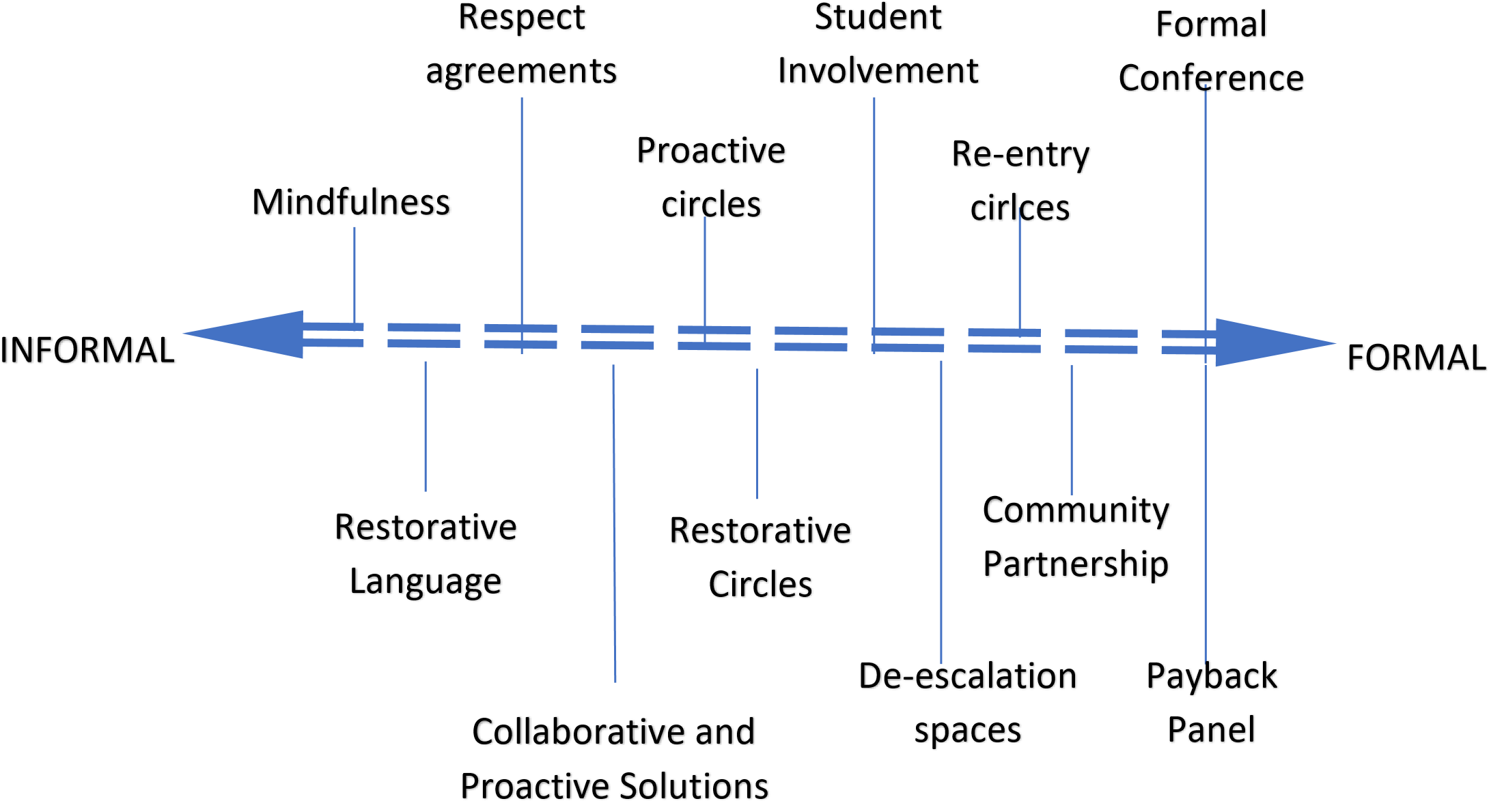

The expanded continuum of restorative processes from informal to formal

Restorative approaches are based on four key features:

- RESPECT: for everyone by listening to other opinions and learning to value them
- RESPONSIBILITY: taking responsibility for your own actions
- REPAIR: developing the skills within our school community so that its individual members have the necessary skills to identify solutions that repair harm and ensure behaviours are not repeated
- RE-INTEGRATION: working through a structured, supportive process that aims to solve the problem and allows young people to remain in mainstream education (RestorativeJustice4schools).
Learn 4 Life school adopt a trauma informed and restorative discipline approach to building our school culture and workforce development of restorative skills. We have staff trained in these areas and who frequently refresh their CPD on this approach.

The four elements of a restorative school culture

•
Outside referrals
•
Community
Partners
•
Community
conferencing
•
Trust
-
building circles
•
Academic circles
•
Respect agreements
•
Collaborative and
proactive solutions
•
Restorative
circles
•
Re
-
entry circles
•
peer mediation
•
Teacher
-
to
-
student
or teacher
-
to
-
teacher
•
Nonviolent
Communication
Restorative
Language
Repairing
Relationships
Rebuilding
Community
Community
Building

The five Skills of Restorative

The Skills of
Restorative
Empathy
Listening without
judgement
Reassurring
Regulate
Honest Expression
Speaking without
judgement
Affective statements
Trading praise for
gratitude
Asking Questions
Going deeper
Drilling down
Indentifying problems
The Art of Requests
Problem
-
Solving
Action Plans
Assessing
Connection requests
Mindfulness
Self
-
care
Presence
Modelling

Learn 4 Life ‘Payback Panel’
Where C&YP may have caused damage to school property, belongings of employees or their peers, Learn 4 Life School have adopted a panel who assess the nature of the harm done, the reasons behind this and the impact on others. This is explained to the young person and their carer/significant other (where appropriate) at a chaired panel meeting, where the learner has the opportunity to reflect on their behaviour and its impact by completing “my side of the story.” They are given the opportunity to work with the school to repair and restore any harm done. This will conclude in the C&YP providing an agreed type of payback in the form of either financial payback if deemed appropriate, reasonable, and justifiable or the C&YP agreeing to undertake some basic simple tasks around school to either support the repairing of the damage or cleaning and or improving the school and community environment.

BEHAVIOUR INTERVENTIONS Trauma Informed Principles
- Throughout the organisation, all Learn 4 Life School employees and the C&YP they serve feel physically and psychologically safe
- Learn 4 Life believe in resilience and the ability of individuals, organisations, and communities to heal and promote recovery from trauma.
- All interventions employed by Learn 4 Life take full account of the fact the majority of our C&YP have experienced ACE’s and childhood trauma and our universal precautions approach.
- School exclusion itself, can be a traumatic experience for most C&YP and negatively impact on their attitude to self and school. Many continue to be involved in situations that re-traumatise.
- All Learn 4 Life employees use evidenced based practice to ensure the wellbeing, physical and psychological safety of all C&YP.
- All staff working directly with C&YP must read the ‘Pupil Passport’ and EHC plans to fully understand the needs and appropriately adapt and differentiate any interventions delivered to incorporate the suggestions/directives made in the plan.

De-escalation and Non-Confrontational Approaches

The best chance of successfully implementing strategies to modify behaviour is to build excellent working relationships between staff and pupils. The philosophy of using non-confrontational approaches when communicating with others is central to the school’s ethos.

Our staff team have been trained and supported in acquiring and maintaining a comprehensive package of de-escalation and positive handing strategies by our own inhouse qualified Team Teach trainers. We embrace the Team Teach approach which emphasises the use of verbal and non-verbal de-escalation techniques to reduce instances of aggressive behaviour and the need for positive handling. All staff are trained and conversant in the use of de-escalation techniques and receive refresher training on an annual basis as well as refresher briefing sessions during the term or as need is identified. The Team Teach website provides a full explanation of this approach. http://www.team- teach.co.uk/introduction_Aims.html

Positive Handling/physical interventions
The positive application of reasonable and proportionate force to ensure, by physical means alone, will only be used in the best interest of the child and to ensure that a child or any young people do no serious injury either to themselves, a member of staff, another child, young person, or extensive damage to property and will:
- rarely used, and only after all other interventions have been exhausted, and wherever possible by staff who have had the accredited, up to date, ‘Team Teach’ training
- only be used if the child or young person is putting themself or others in danger and where failure to intervene would constitute neglect or a criminal offence
- be recorded within the negative slip process on the CPoms recording system and documented in the Individual Behaviour Change plans, Positive Handling Plans and Individual Education plans.
- an Individual Risk Assessment will need to be carried out – this might apply when an individual child or young person needs physical interventions using Team Teach strategies as a part of an on-going behaviour management plan.
- staff must understand the possible consequences of using a particular Team Teach method or methods of physical intervention when difficult behaviour occurs.
- A full report, and post incident debrief, must be held, to facilitate learning and to share information
- parent/carers must be contacted before the child arrives home
Holding - by this we mean providing physical direction e.g., C&YP led away by hand/arm/shoulder (using Team Teach practices)
- it falls short of positive handling
- it is subject to considerations of sexual appropriateness and sensitivity
- is subject to interpretation, so must be used with care

Touching
Touch is a valuable part of managing behaviour, and socialising skills, and may be used appropriately e.g., a handshake, pat on the shoulder, side hugs always in a public place and always taking the needs of the child or young person in to account

Restricting liberties- our C&YP will never be
- locked up
- left alone/unattended as a punishment
- deprived of food/drink
- denied access to a toilet
- subjected to any degrading or humiliating treatment

Keeping the whole school safe
Managing and changing negative behaviours helps to keep our whole school safe. To achieve this, we encourage C&YP to:
- tell an adult, if they see or know that someone is doing the wrong thing. We explain that this is how we look after each other – that it is a good and caring thing to do. Any child or adult who witnesses inappropriate behaviour and says or does nothing is an accessory to that behaviour; is colluding with the wrongdoing and giving permission to the perpetrator to do it.
- we do not accept the concept of “grassing” or that drawing attention to inappropriate or negative behaviour is a bad thing. Instead, we challenge this view and encourage and applaud this action as part of being a good British citizen and caring individual.

Exclusion
(Please see exclusion policy for full details)
Learn 4 Life School is an inclusive school:
Our target is to have minimal fix term exclusions and no permanent exclusions; we use fixed-term exclusions only to mark unsafe behaviour and inappropriate behaviour choices that break the law and cause serious concern related to the health and safety and safeguarding needs of other C&YP, staff, and members of the community if this is relevant to the incident(s).
Fixed term exclusions are only considered where there is clear intent to break the rules and where the behaviours are not due to the SEND needs of the C&YP in question (as required by the SEND Code of Practice 2015)
Permanent Exclusion will only be considered as an ultimate last resort, where every other avenue has been exhausted, consultations with all relevant parties concluded and where the to continue with the placement would put the child or young person, or another person at risk of serious harm.
Any type of exclusion can only be made with the recommendation of the school’s internal inclusion panel which consists of a minimum of 3 SLT members and a final decision being approved by the Executive Head and/or Proprietor.

MONITORING
We apply a consistent behaviour management approach throughout the whole school, appropriately adapted to the age, abilities, and characteristics of the C&YP
- we will observe and feedback to staff on observed good practice and areas for development as part of the supervision process
- the SLT will assess, plan, do, review as part of our on-going school improvement plans.
- The school operate an attendance, engagement of learning, safeguarding and behaviour management monitoring process called the WATCH. The WATCH meeting takes place weekly and is attended by the senior leadership team as well as the teaching staff to monitor our school information, assessment, and recording systems and to discuss, analyse data, and make action plans to promote and enable the improvement of C&YPs attendance, engagement in learning, behaviour and personal development and ensure our school staff are consistently and professionally implementing our schools’ policies, procedures, and practices.
- The SLT will report to the CEO of Governors about attendance, general behaviour issues, interventions, and any specific concerns.
- Regular feedback will be sought from employees, C&YP to continually improve behavioural and learning outcomes

CONTINUING PROFESSIONAL DEVELOPMENT
To promote a whole school approach and maintain a consistent application of our adopted evidence-based approaches and to further improve the skills, knowledge, and values, staff will
- attend compulsory whole school, and team training sessions on behaviour management
- can apply to attend courses, as part of their individual CPD
- ask for in-house individual development opportunities e.g., by observation and learning dialogues with staff, with identified best practice
- use the varied CPD resources available throughout the school, and online
- use own initiative in independent reading of articles, books, and journals on best practice related to behaviour management and other relevant practice.
- access the learning and practise development resources, articles, books, and information made readily available

Staff Wellbeing - to take care of our people and promote healthy skilled emotional available adults
Although educating, supporting, and promoting C&YP’s wellbeing is personally and professionally rewarding and is one of the most important responsibilities that adult professionals can undertake, we do understand, acknowledge, and respect the high level of compassion, commitment, dedication, and emotional resilience it takes to support our C&YP and foster our approach to implement our integrated therapeutic, compassionate, and restorative approach to crisis intervention, discipline, behaviour change and personal development.
Using the analogy of the advice given by airline stewards ‘to ensure you put on your own oxygen mask before supporting C&YP and other vulnerable people with their masks. We advise, support and guide staff to practice promote and focus on their own wellbeing and development of self-regulation, and emotional resilience and emotional intelligence. We wish for our staff to learn and practice self-compassion, self-care, give themselves time to recover, restore and prepare, and ensure they effectively use planned breaks, work as a unified supportive team, utilise the support on offer, manage time effectively and delegate appropriately wherever possible.
We therefore ensure that staff wellbeing is fully supported at our school by the following processes and practices:
- Weekly staff debrief meetings following our adopted Trauma and Mental Health Informed Schools UK approach of Protect, Relate, Regulate, Reflect, and Restore staff debrief meetings at the end of the school day (minimum of twice per week)
- Staff CPD plan, briefings, training, and twilight sessions to implement and support the whole development of knowledge, skills, and values to support our staff in building a safe and successful trauma informed restorative school.
- Regular staff supervision (6 weekly)
- Specific wellbeing training and support including emotional literacy and resilience – delivered by Local Authority – Services to Schools Educational Psychology Service.
- Staff well-being action plans (WAP) codesigned by staff and line managers as part of the annual supervision and appraisal process.
- Post incident debrief including the project, relate, regulate, reflect, restore approach to support staff and areas of learning for staff and school.
- Staff wellbeing day – a special additional staff leave day with the condition of staff being required to do something that promotes their wellbeing.
- No school formal communication and information sharing between 7p.m. and 7a.m. via emails and or phone calls/text (unless an emergency)

Conclusion
In conclusion, through this policy we have articulated our philosophy, underpinned by evidenced based research and practise, on how to understand the underlying causes of behaviour and then consistently and compassionately work to change behaviour, from negative to positive. Through this approach, teaching and supporting skills and attitude and personal development and addressing unmet need, we support C&YP to progress and fulfil their potential.
Working Collaboratively to ensure that Learn 4 Life School is a positive, fulfilling, happy and rewarding place to be.

Appendix 1 - PAS Sheet

 | Pupil Name |  |  | Pupil  Name |  |  |  | Pupil  Name |  |  |  | Pupil  Name |  |  |  | Pupil  Name |  |  |  | Pupil  Name |  |  |  | Pupil  Name
Monday | E | B | H |  | E | B | H |  | E | B | H |  | E | B | H |  | E | B | H |  | E | B | H |  | E | B | H
REGISTRATION
ENGLISH
ENGLISH LIT
MATHS
LUNCH
SCIENCE
HISTORY
CITIZENSHIP
PSHE
PE
LEARNING
SUPPORT
SOCIAL/PD
VOCATIONAL
FOR OFFICE USE ONLY

E = effort to learn
B = behaviour choices
H = house points – getting on with others

Every child/young person is awarded a mark from 0 to 5 in every session for ‘effort to learn’ and ‘Behaviour choices’. House points are awarded for getting on well with others – one point issued for each lesson.

The scoring criteria for the two main reward categories are:

5 | Perfect choices | Perfect means just this. If a child isn’t engaged for the entire lesson, then they can’t earn this score for effort.  Swearing once is not perfect behaviour.
4 | Excellent choices | Not quite perfect
3 | Good choices | Most of the student’s contribution are positive.
2 | Some good choices | There are enough positive things to focus on.
1 | A few good choices | Most of the interactions have not been positive and there is minimum engagement.

Appendix 2

Punitive vs. Restorative Approach to School Discipline

Punitive | Restorative
Misbehaviour is defined as an individual choice to break school rules or to deviate from established behaviour expectations. | Misbehaviour is defined as harm done to one person/group by another as a result of a breakdown in community relationships and/or unconscious attempt to meet needs.
Focus is on what happened, establishing guilt, and fairly dispensing punishment to the wrongdoer(s). | Focus is on understanding feelings, needs, and responsibilities of all impacted individuals and exploring ways to bring about community healing.
Discipline interventions are focused on making the harmful behaviours stop, using increasingly restrictive and/or exclusionary consequences. | Discipline interventions aim to understand root causes of misbehaviour and offer relational support for positive changes in behaviour.
Discipline interventions decided on by one or more authority figures. | Discipline interventions emphasize collaboration with direct victims and other impacted persons regarding how their needs can be met.
Accountability defined in terms of receiving punishment. | Accountability defined as understanding impact of actions, taking responsibility for choices, and finding ways to repair harm and prevent future harm.
Imposed punitive consequences have the effect of shaming and stigmatizing students who have caused harm. | Restorative processes offer an opportunity for students who have caused harm to understand the source of their behaviour, take  responsibility for their choices, and to learn and grow from the experience.

(RestorativeResources.org adapted for Learn 4 Life School) Appendix 3

Promotion of person-centred, co-design, and collaborative approach to supporting C&YP to Thrive.



TO
People as objects to be managed
Memory and executive functions hampered
Power
-
over
CPS: problems as objects to ignore
Brain state: reactive defensive
WITH
People as subjects to be honoured
Builds pro
-
social attunement, connection, and
accountability
Power
-
with
CPS: Problems solved collaboratively
Brain state: Relaxed alertness
NOT
People as objects to ignore
Distress, negative impact on attention ,
memory, emotions, and behaviour
Power
-
Over
Brain State: Hyper
-
vigilance
FOR
People as objects of need
Connects behaviours with positive feelings, which
reinforce negative behaviours
CPS: problems solved by adults
Power
-
under (disempowered)
Brain state: Passive enabled
The
Relationship
Matrix
Low

High

High

Support (for being human)

Modified by Joe Brummer from the Relationship Matrix by Evans and Vaandering (2016)

Appendix 4 – CPS and Lagging skills forms and guidance

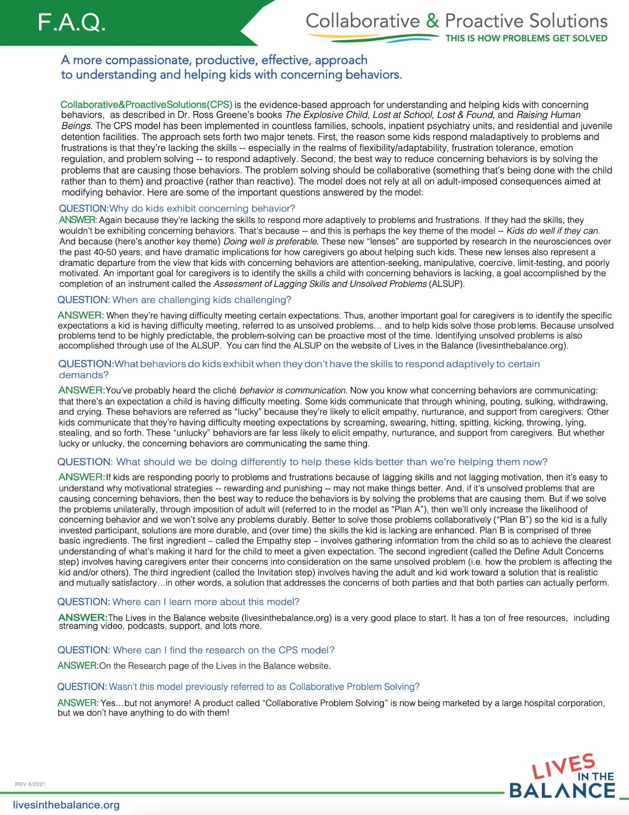

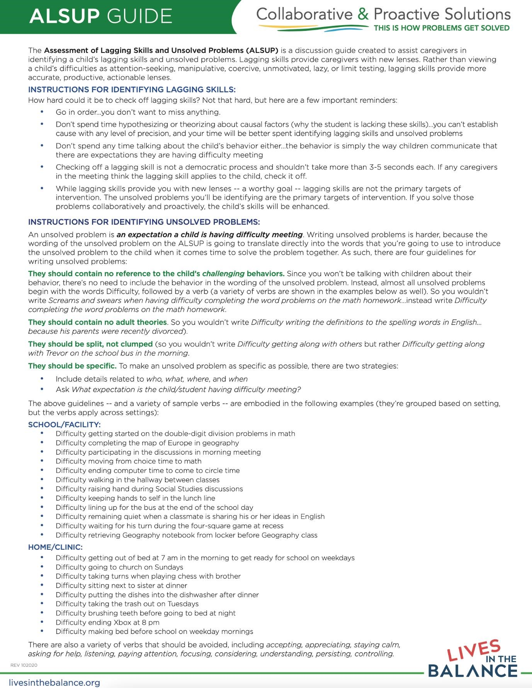

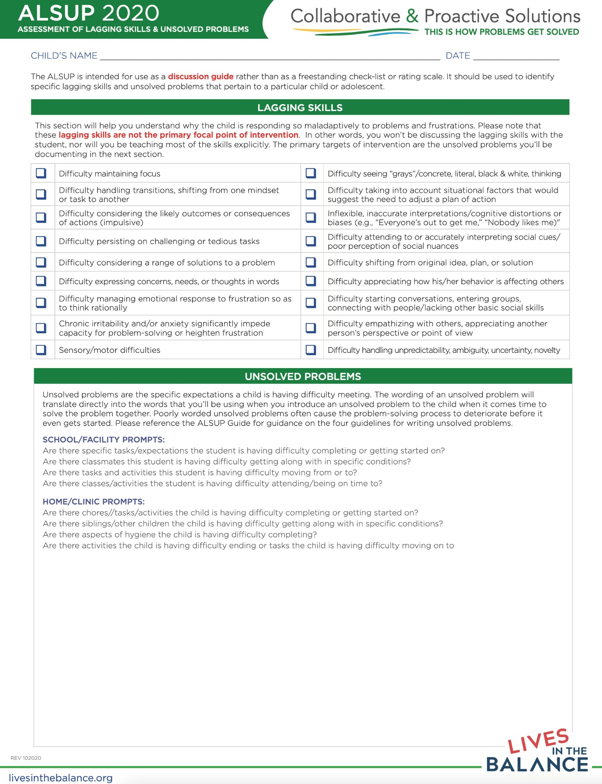

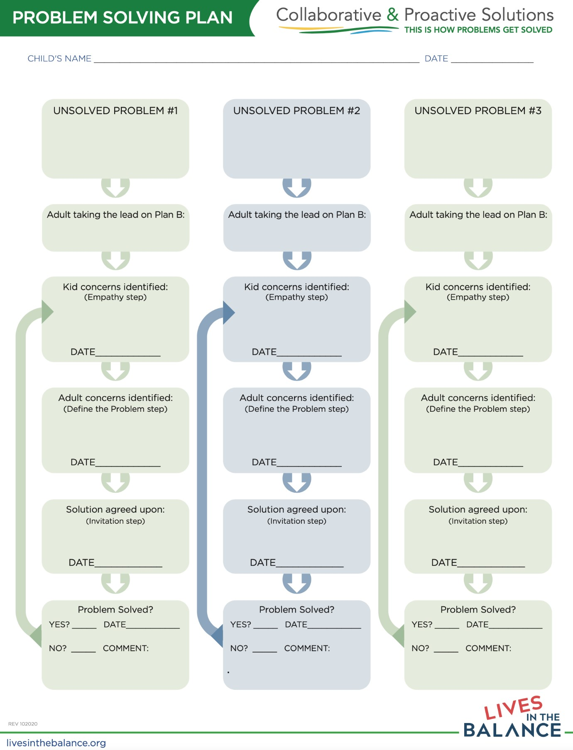

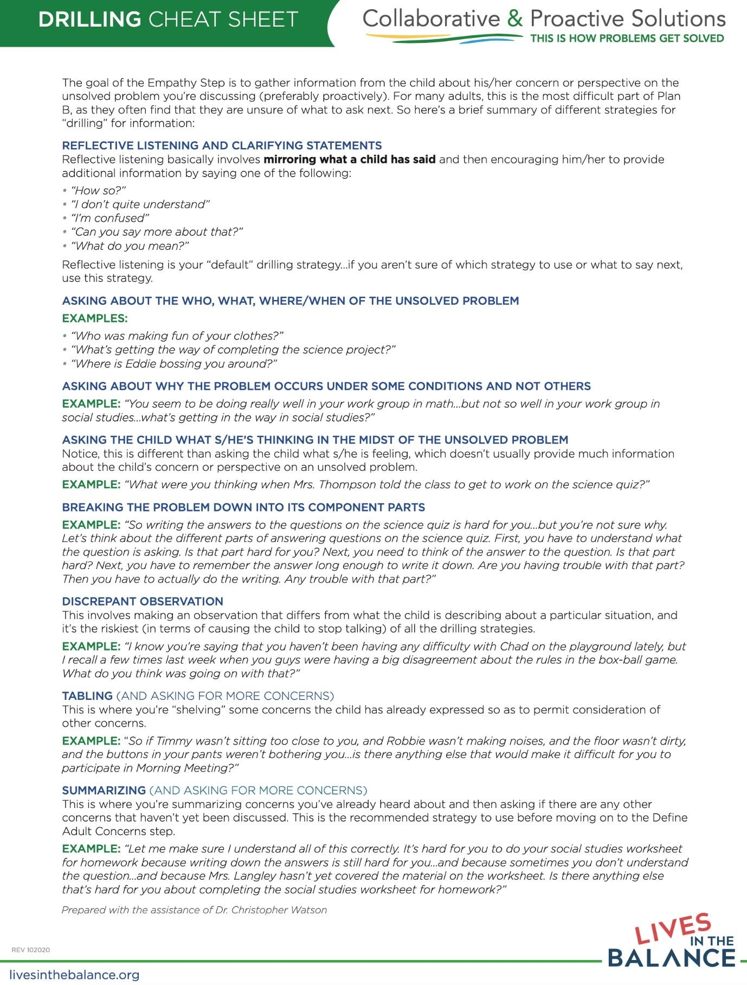

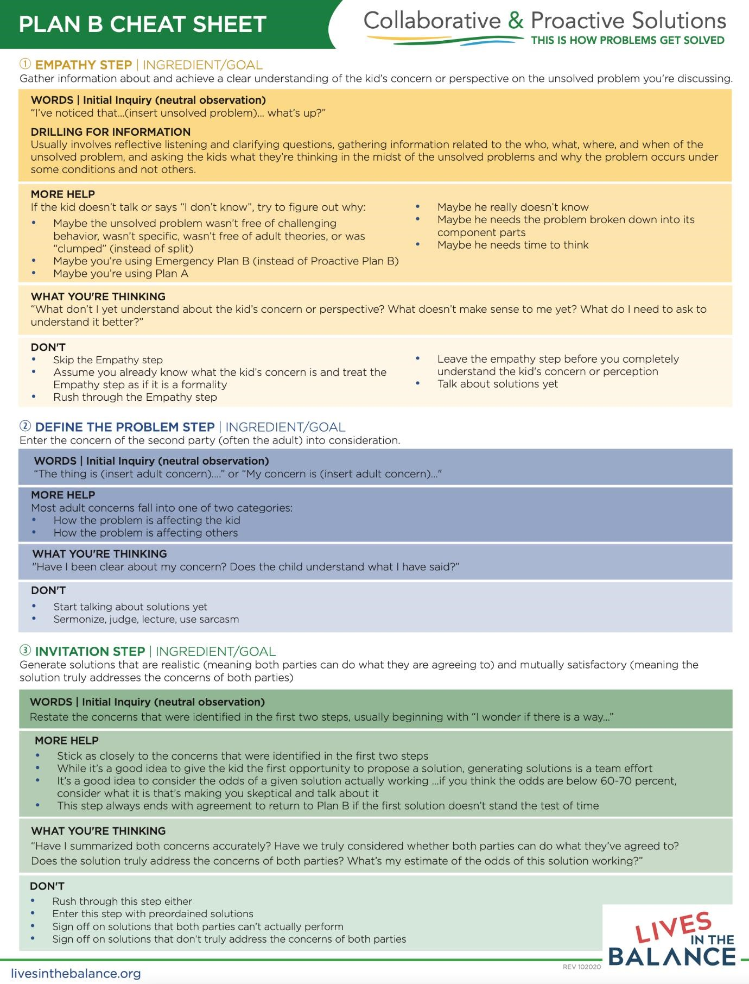

Appendix 5 Restorative Resources
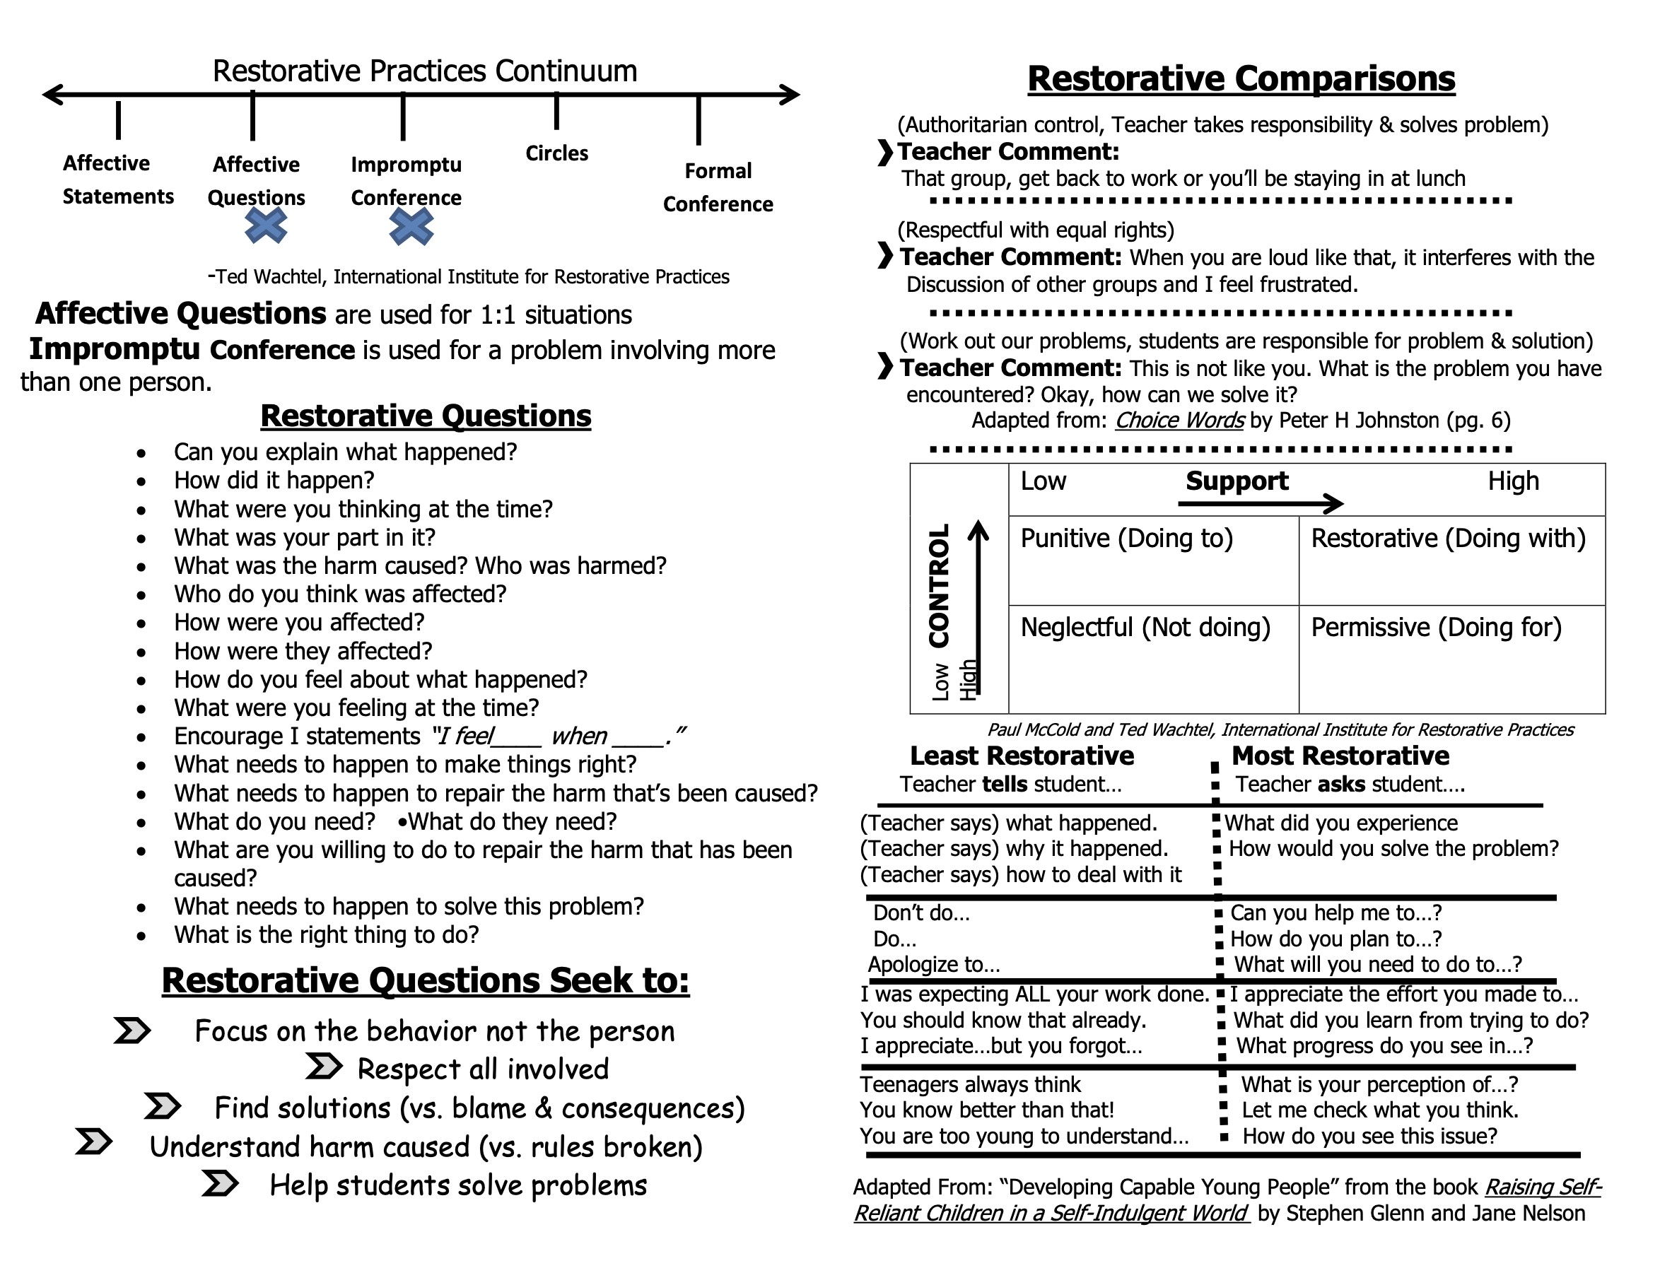

Appendix 6 – Basic Brain-Based Resource

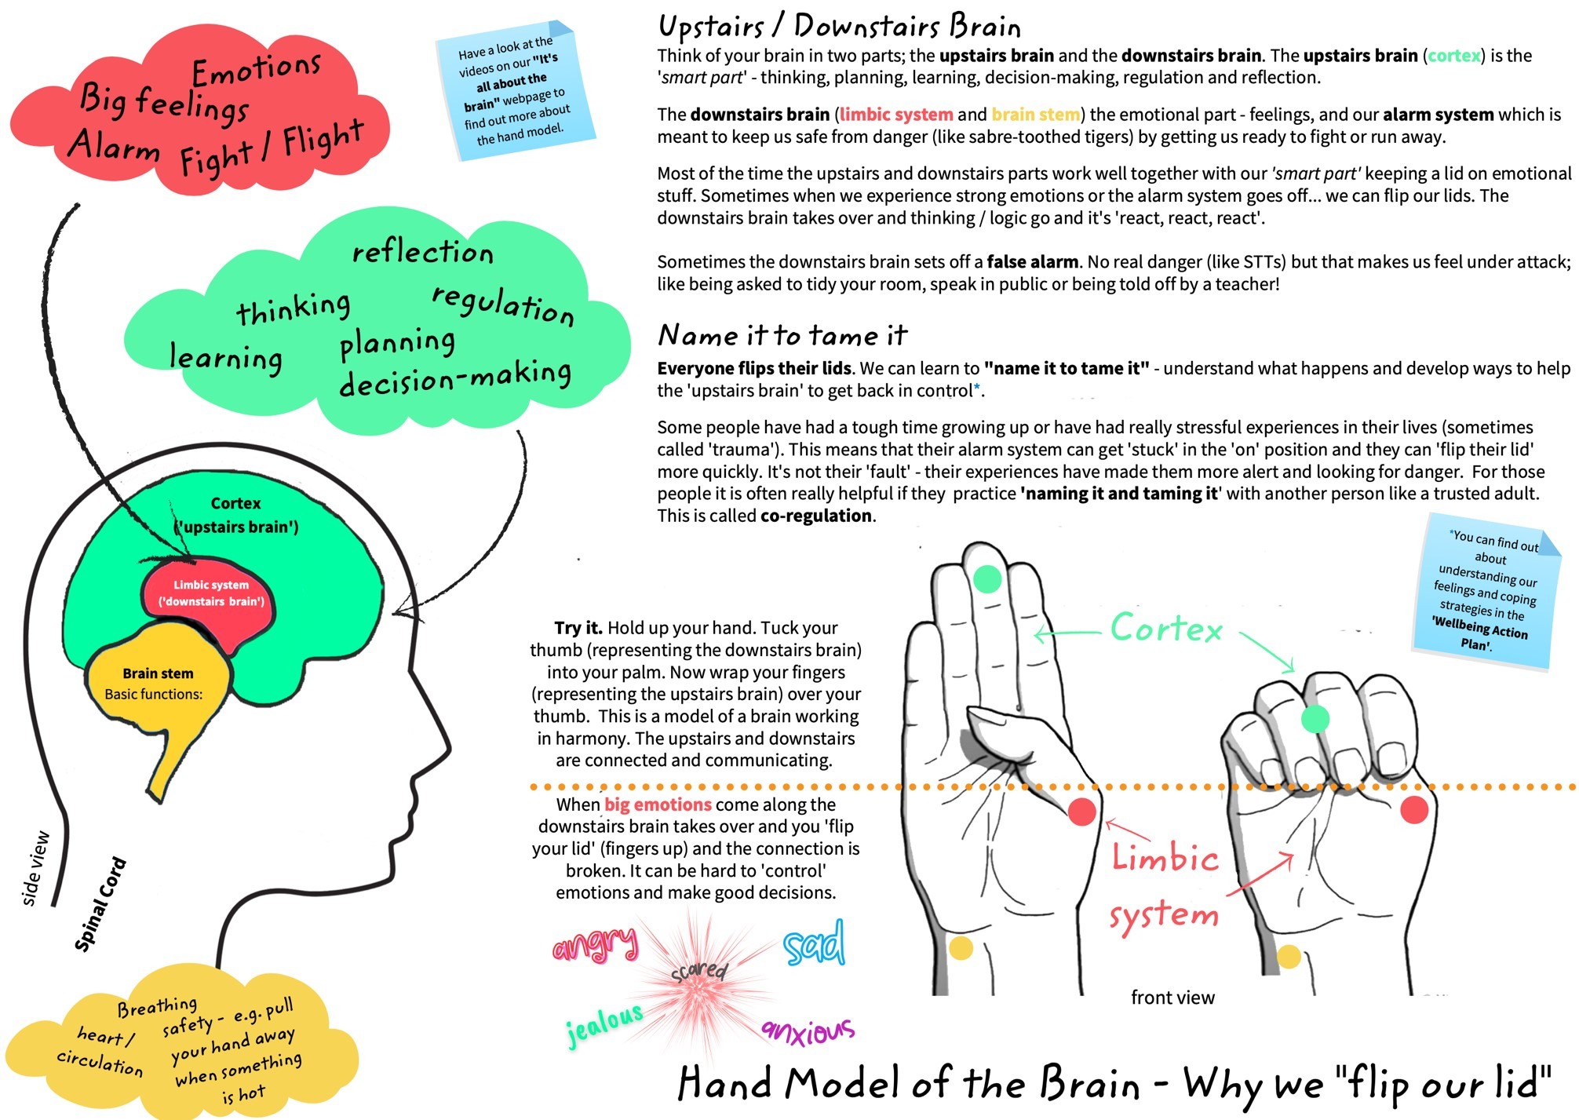

Appendix 7 – Payback template letter to C&YP and Parents/Carers


Learn 4 Life School
64a Rectory Road
Ashton in Makerfield
WN4 0QD
01942 466 318

NOTIFICATION TO ATTEND: THE PAYBACK PANEL Name of Young Person:
Dear parent/Carer
As per our telephone conversation today, we would like you to attend the payback panel meeting for CYP. This will take place at:-
Place: Home Address or School

Time:
Day:
School CPOMS records show that___________ has been involved in an incident whereby their behaviour was deemed harmful and unacceptable and or caused significant damage to property. As a consequence, for their negative behaviour, Learn 4 Life School ask that you attend The Payback Panel with your Child/Young person.

A member of our SLT team will chair this panel. The Chair will look at the evidence that is recorded on CPOMS, The young persons account and views and any remorse shown, and will also consider the cost and harm done to the victims as a result of young person’s behaviour.

You have a right to see the exact same evidence that the chair will have, and this is enclosed with this letter. The young person’s key teacher or any member of staff from school will attend to support them. The young person may want to take a student representative to the meeting to support them if this is deemed suitable. It is acceptable to have any significant other such as a support professional invited to attend. They will be contacted by telephone call or letter prior to the meeting taking place.

The chair of the panel will look at all the facts and circumstances surrounding the incident and listen carefully to young person’s side of the story before making a final decision.

The purpose of the Payback Panel is to allow young people the opportunity to reflect on their negative behaviour and where possible allow them the opportunity to “put things right and repair the harm”.

The ‘Payback Panel’ Chair will explain how this might happen. You should also know that the Chair is acting on behalf of the victims and the school, in line with British law, may have to involve the police, if young person’s behaviour is deemed criminal.

It is in young person’s best interests to attend the panel, as this will give them a chance to explain their behaviour, and to show anything positive they have done since the incident happened. This can include apologising for their behaviour and to any victims involved and or offering to repair any damage caused.

If young person chooses not to attend, the chair has the option to make a final decision without them being present.

Attached with this letter is guidance giving more detail about the purpose and procedures surrounding the Payback Panel.

Yours faithfully

James McAlpine
Headteacher
Learn 4 Life School
64a Rectory Road
Ashton in Makerfield
WN4 0QD
01942 466 318

Enc

Appendix 8 – Collaborative agreement and acknowledgement template letter to Parents to be signed by parents/carers to consent and agree to supporting this School policy

Learn 4 Life School
64a Rectory Road
Ashton in Makerfield
WN4 0QD
01942 466 318

Dear Parent/Carer,
Thank you for spending the time to read through the following School Policies:

- Attendance policy
- Anti-Bullying Policy
- Exclusion Policy
- Positive Behaviour and Restorative Discipline Policy
- Safeguarding Policy
- Search and Screening Policy
You will be offered support and guidance of the above policies if required during your child/young person’s induction period. We will be invited to attend a coffee morning to go through the policies and our approach to educating and supporting your Child/Young person’s behaviour, attitude, and personal development during an agreed time within the first term of your child/young person’s enrolment to our school and we will continue to offer times throughout the year for us to work together, and seek your views, support, and feedback. We will endeavour to do our best to communicate and work closely with you about your child/young person’s progress including their effort to learn, behaviour choices and attitude to self and school and their personal development and achievements.

Can you please sign below to acknowledge receiving these Polices and to consent to agreeing to work collaboratively with the school in supporting the implementation of these policies in the best interest of your child/young person. We thank you for your continued partnership with us to promote and offer quality education and support to your child/young person

I agree to support the school’s policy implementation related to the above policies.

Parent/Carer Name: …………………………………………………. Parent/Carer Signature:…………………………………...
Date:………………………………………………

Appendix 9 – Raise Positive Behaviour and Restorative Discipline Policy – A Three-year Implementation plan

System changes
Code of conduct
Revised Policy: Positive Behaviour and
Restorative Discipline policy
SLT walks, inspections, and
meetings
Community partnerships with other
likeminded schools and organisations
Parents/carers and LA partnerships to
understand and support our approach
(
coffee and cake mornings)
Procedural changes
Forms, paperwork, and process diagrams
Referral forms and letters
Meetings schedule i.e. The Watch, Payback
panels, circles, Staff PRRR briefing meetings
Policy versus active and consistent procedure
and best practice
Physical changes
Building safety
-
Trauma Informed
Classroom declutter and needs based furniture
Posters
De
-
escalation spaces (Zones of
Regulation/Calm Corners)
Professional development
(
ongoing
implementation)
RestorativeJustice4Schools (basic to specialist)
Trauma and mental health informed
Team Teach (psychology of behaviour
interventions and change)
Emotional literacy and resilience (staff)
Mentoring and coaching in use of CPS and
other assessment and interventions
Outside versus inside training
Build in accountability

